|  |  |
| --- | --- |
| **North South University**  Department of Electrical & Computer Engineering  **LAB REPORT**  Course Code : EEE/ETE 241 L  Course Title: Electrical Circuit 2  Course Instructor: NNP  Experiment Number: 03  Experiment Name:  Series RLC Circuit  Date of Experiment: May, 2020  Date of Submission: January, 2021  Section: 02  Group Number: 04 | |
| Submitted By | Score |
| |  |  |  | | --- | --- | --- | |  | Student Name | ID | | **2.** | Kaniz Fatema | 1520064045 | | **3.** | Mohammed Mahmudur Rahman | 1520386043 | |  |

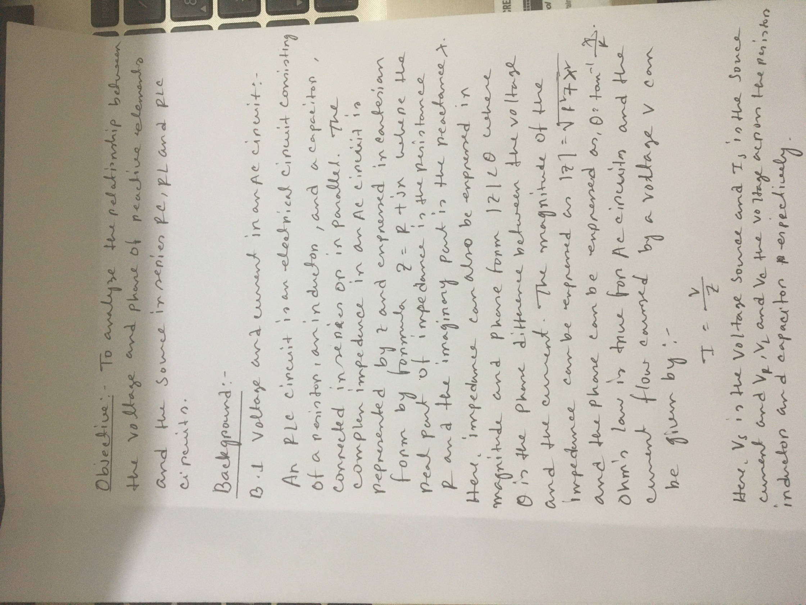

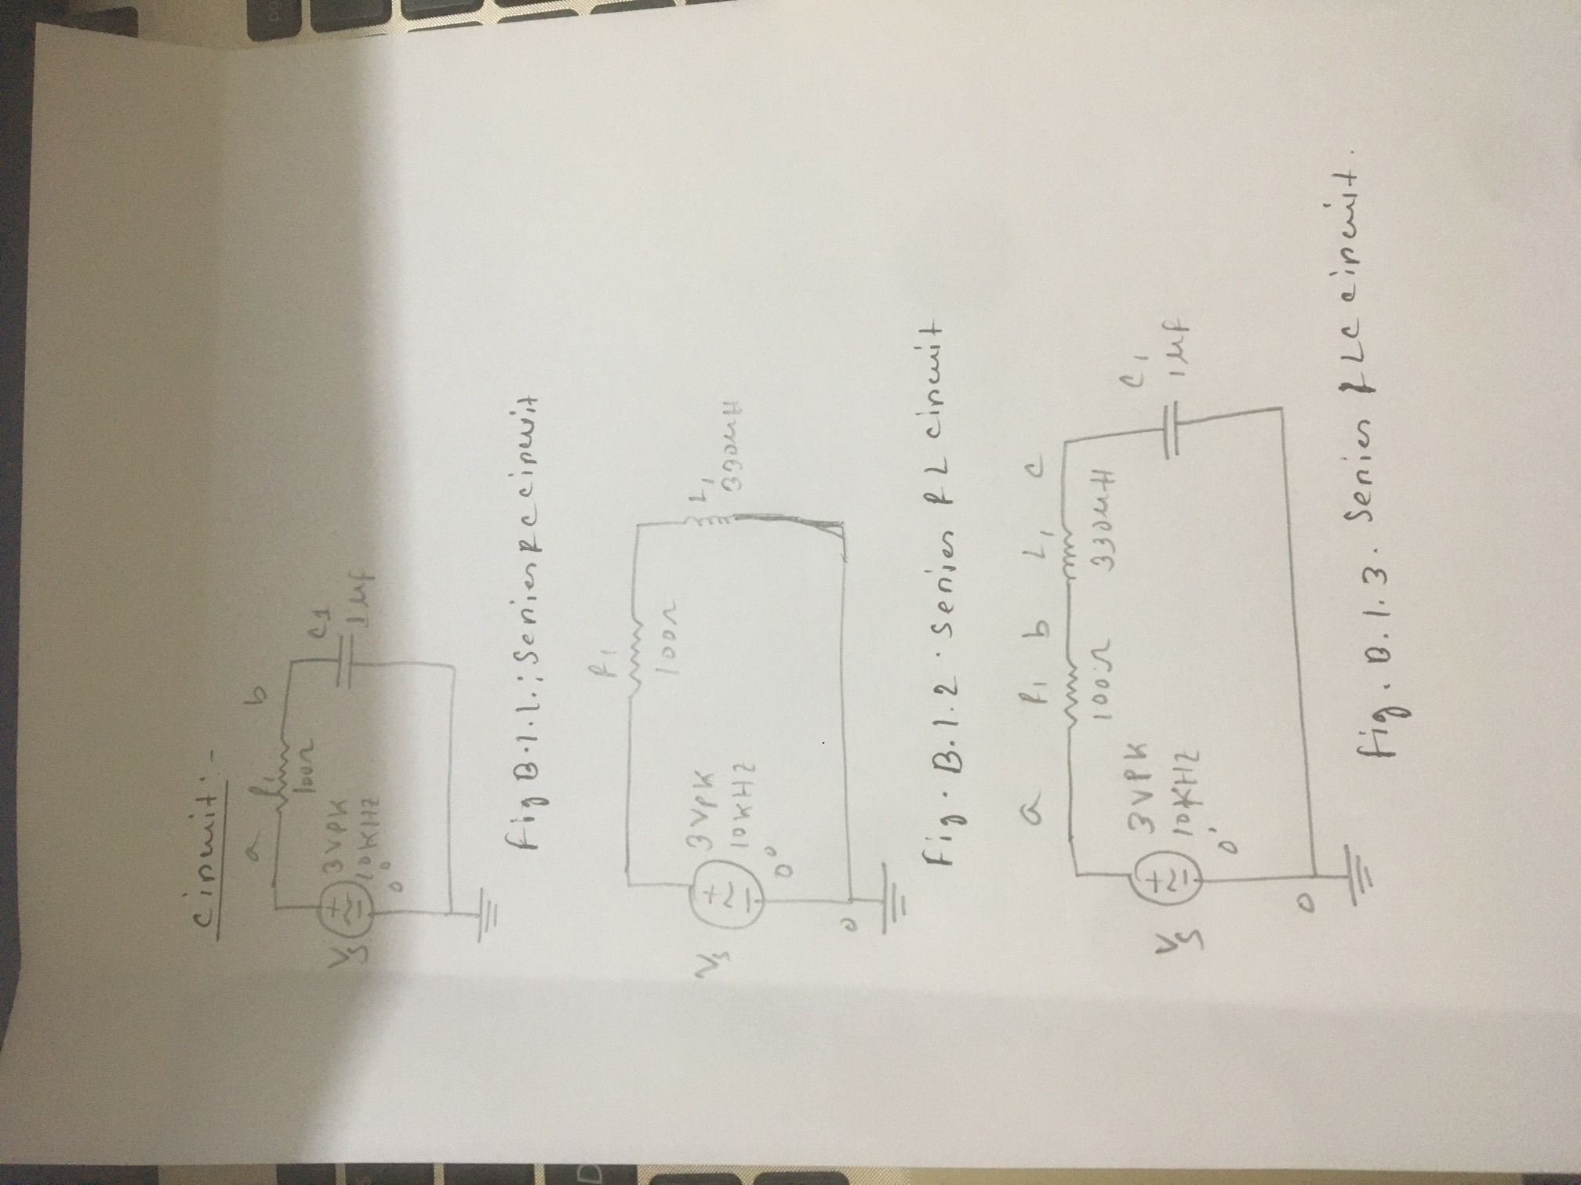

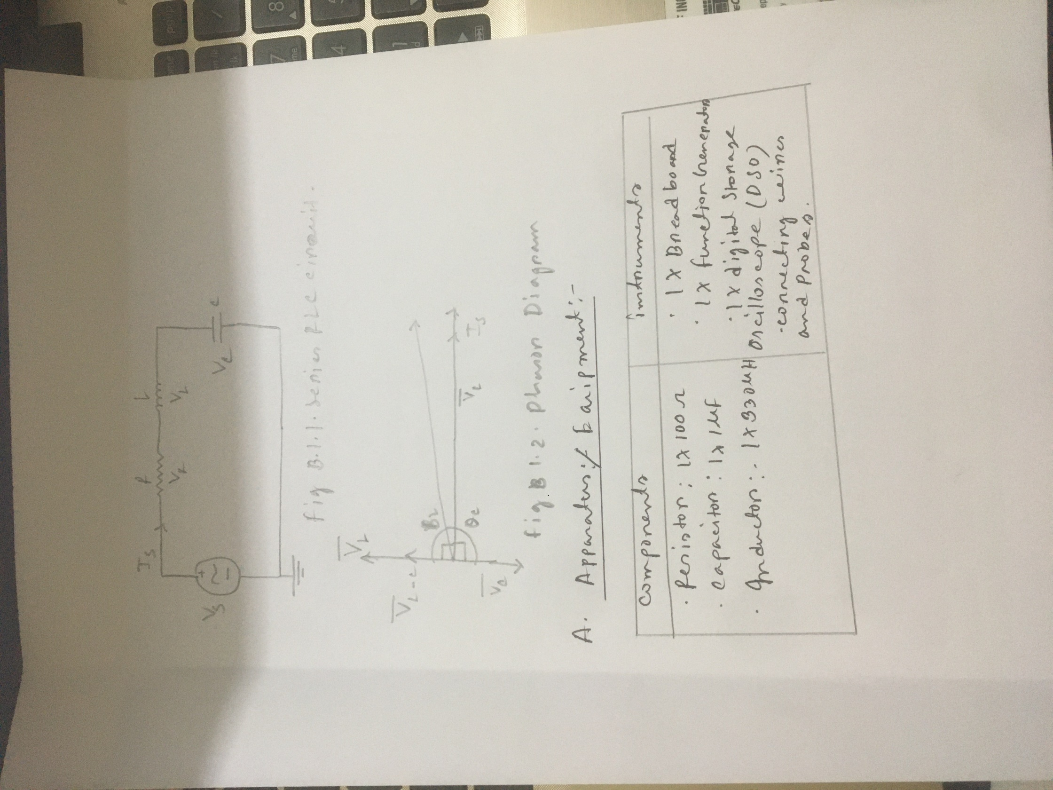

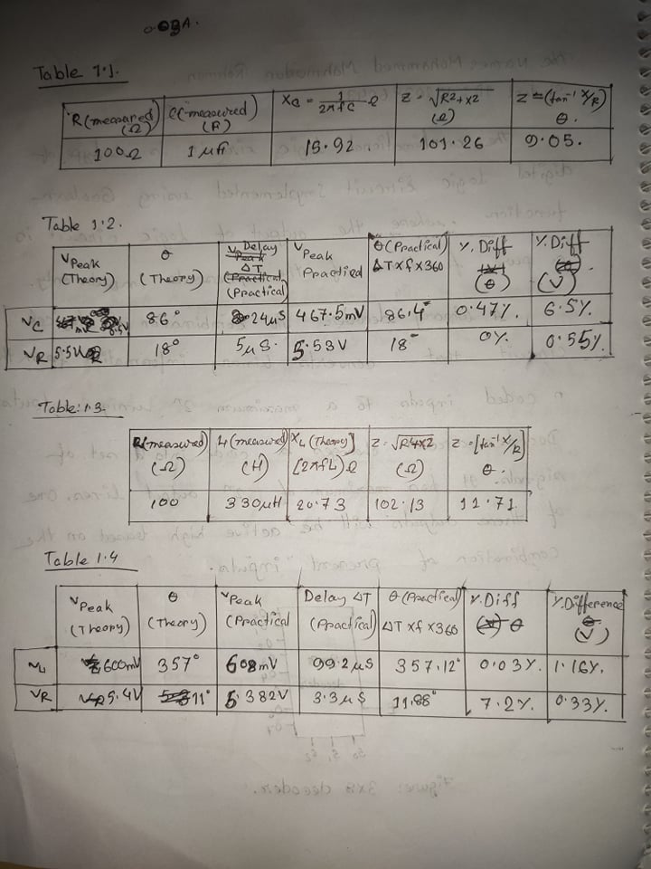

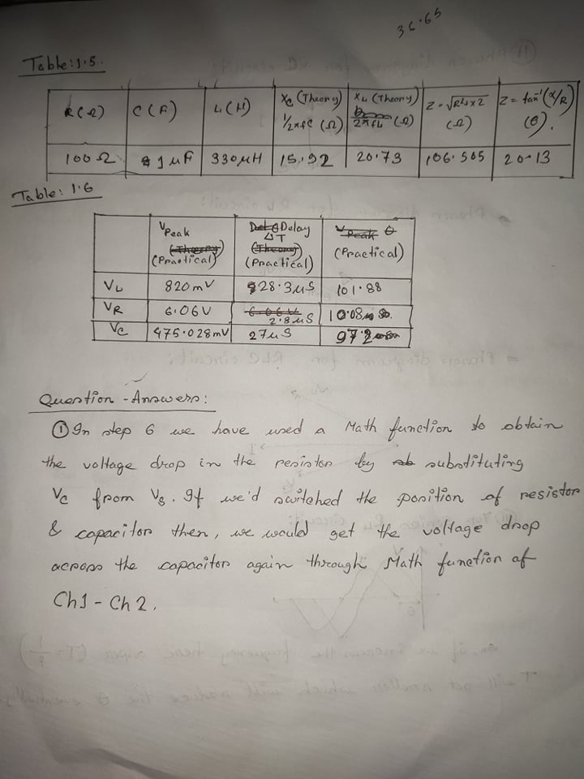

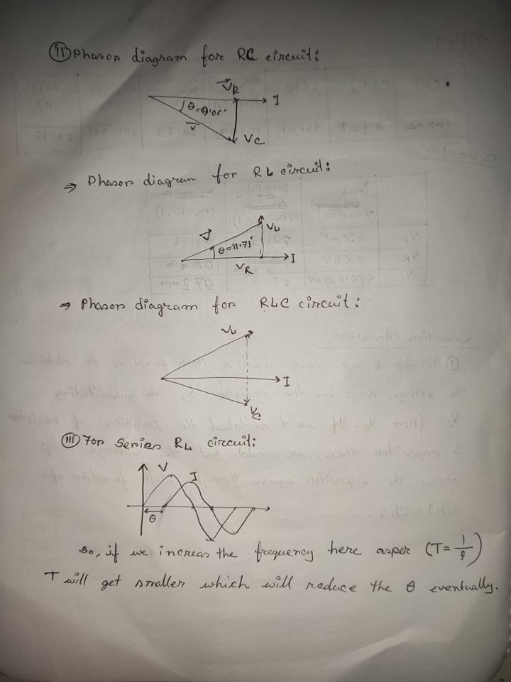

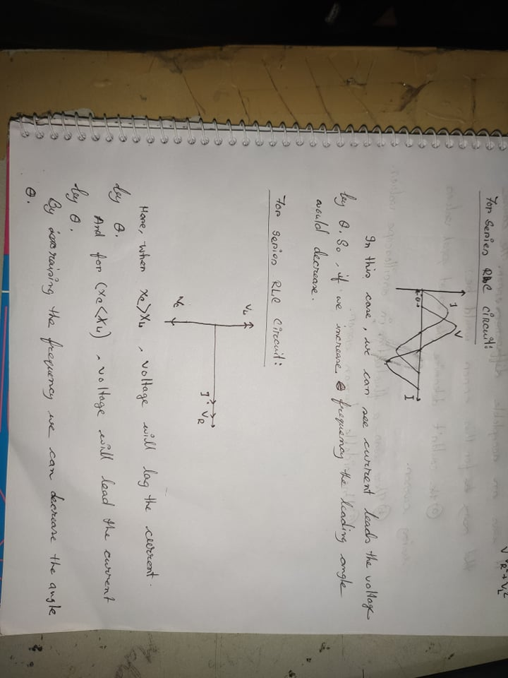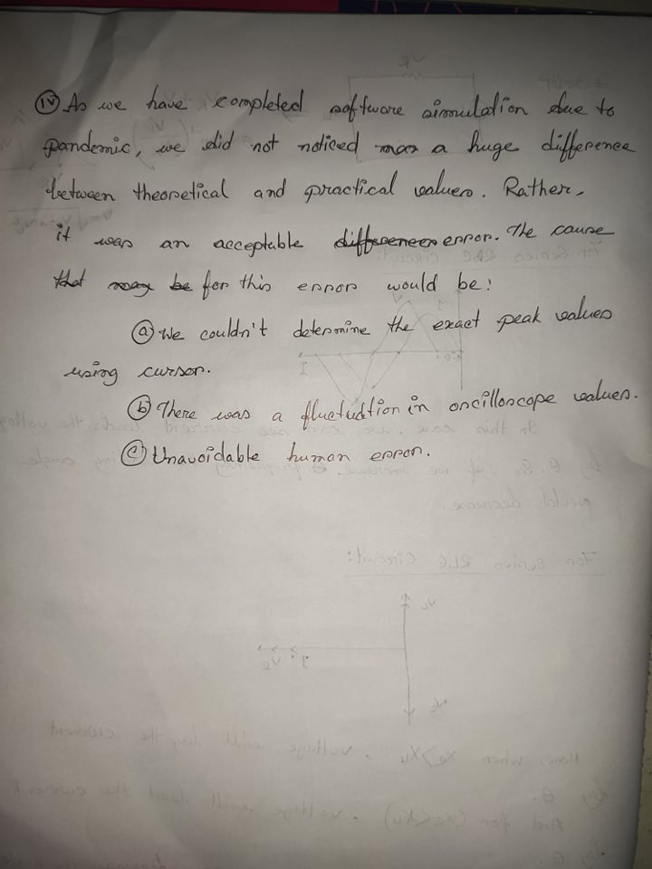

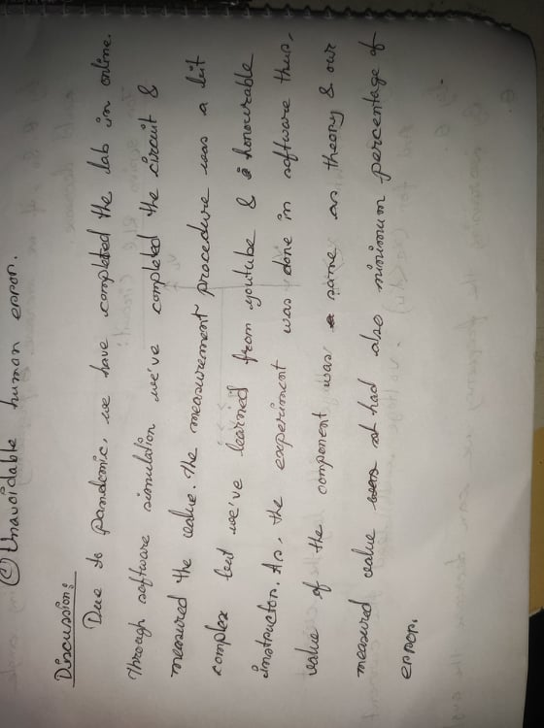

RL Circuit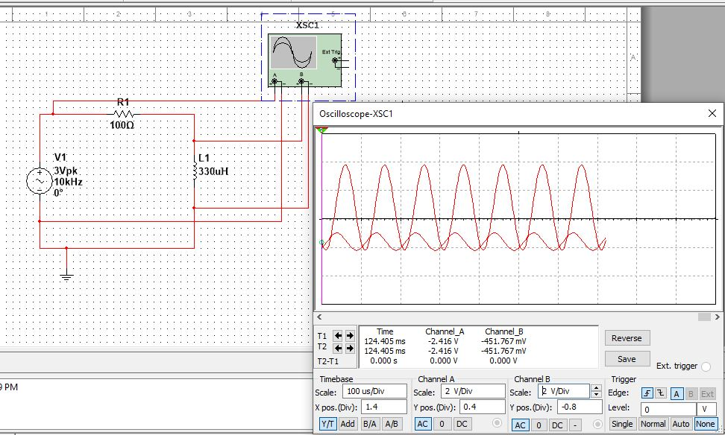

RC Circuit

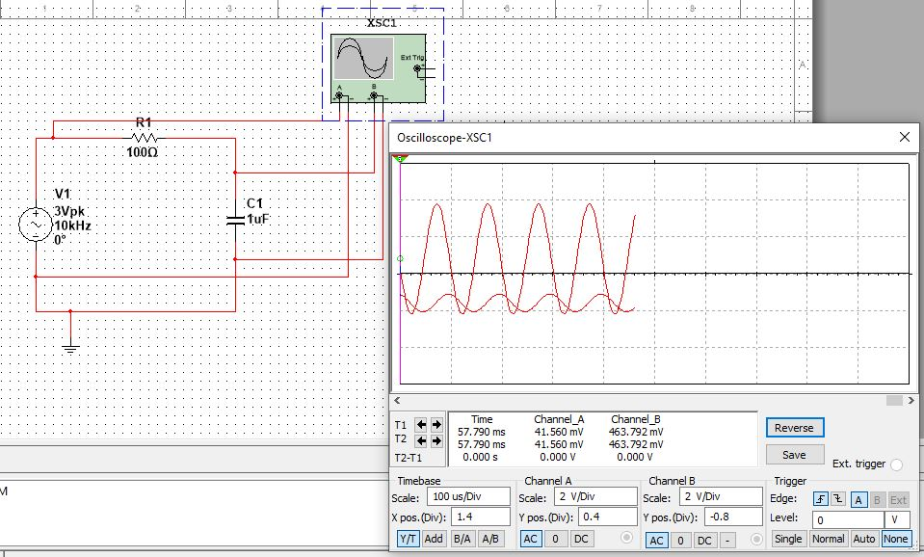

**Math Generated Signal in RC Circuit**

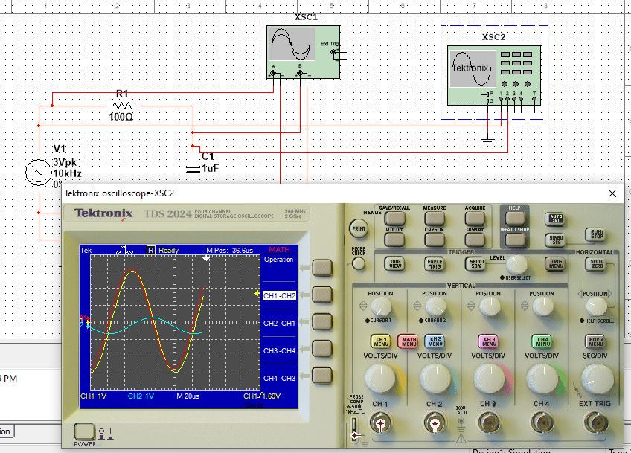

**Measuring Del-T for RLC Circuit:**

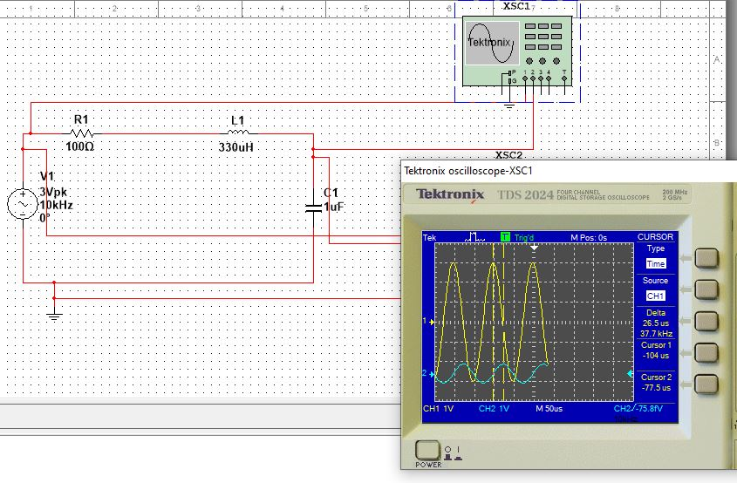

**Measuring Del-T for Inductor in RLC Series Circuit**

